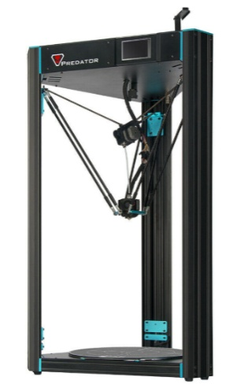

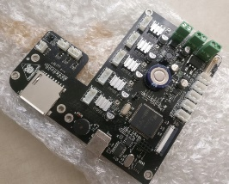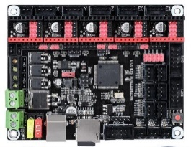Simply manual for swap original anycubic board to SKRv 1.3  
Anycubic Predator Delta 3D Printer

Before you start :

**The author is not responsible for any damage to the device. All changes and modifications are made on your own responsibility. !!**

If you are not sure what are you doing please don’t continue and left printer without any changes or modifications!!

What we need:

* Board SKR v 1.3
* Micro Sd card (included in SKR v1.3)
* TMC 2208 or which you prefer (this tutorial will be for 2208 standalone)
* Display 12864 or LCD2004 + cables exp1 exp2 (Need to choise in FW what you want to use!!
* PlatformIO
* Marlin 2.0 FW
* Small screwdriver
* Tools set from predator

1, Prepare Marlin configuration

Download mine custom version of Marlin FW from GitHub page.

Instal Platformio for Atom or Visual Studio Code

Open FW folder in Platformio

* If you want setup or resetup whatever you want inside is up to you..
* Like TMC and other stuff ..

Setup Jumpers for TMCS

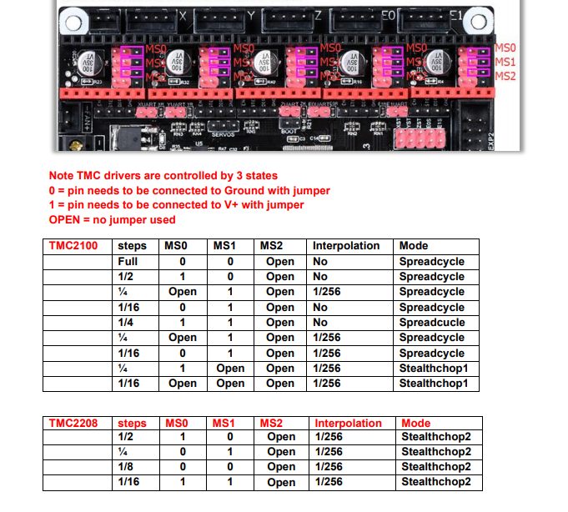

2, fotodocu everything before you fuck it up

3, wiring .. need to change some wires for endstops + and S are wrong for SKR use

* Need to look at original board you will se how it is wired !!

4, setup jumpers on SKR correctly it is up to you TMC choice

5, correctly wire up everything ..

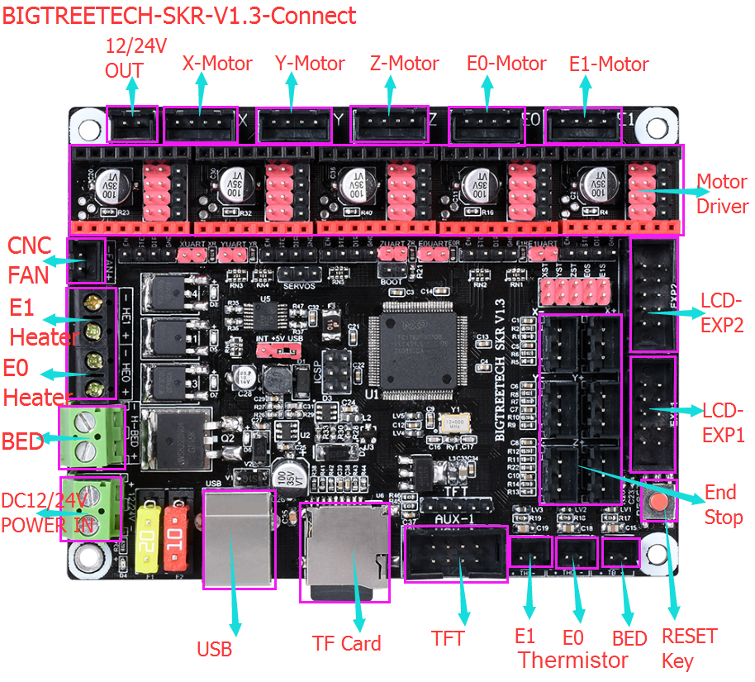

* Pinout for SKR v1.3
* X+ endstop !swap cable + and S
* Y+ endstop ! swap cable + and S
* Z+ endstop ! swap cable + and S
* Z- endstop (probe) ! swap cable + and S
* Themistor BED
* Themistor E0
* DC 12/24 V powersuply
* BED – mosfet control wires
* E0 heater (hotend patron)
* Heater E1 ( this pinout is set for cooling for drivers ) (it starts fan connected here automaticly when printer start moving cause TMC need extracooling )
* CNC Fan – here is fans for cooling on hotend
* 12/24V out – here is cooling for heatbrake (running always)
* X-Motor
* Y-Motor
* Z-Motor
* E0- motor
* LCD EXP1
* LCD EXP2

6, prepare for first run

* Download FW to SD card
* Place SD card into board slot(FWslot)

7, After First run

* Reset Failsafe
* Try to home – check of endstops working correctly also motors moving correctly !!
* After that is OK then run procedures below

DELTA Auto Calibration

1, Select Configuration

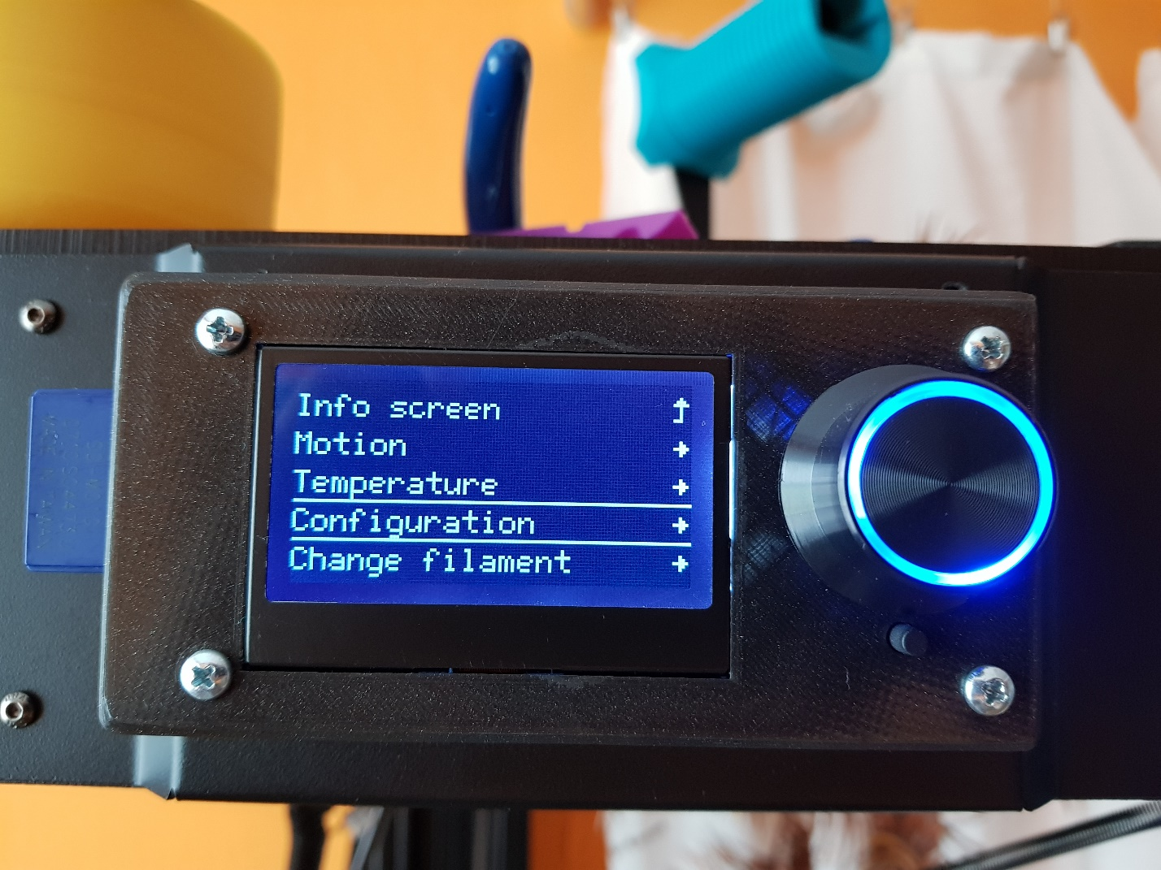

2, Select Delta Calibration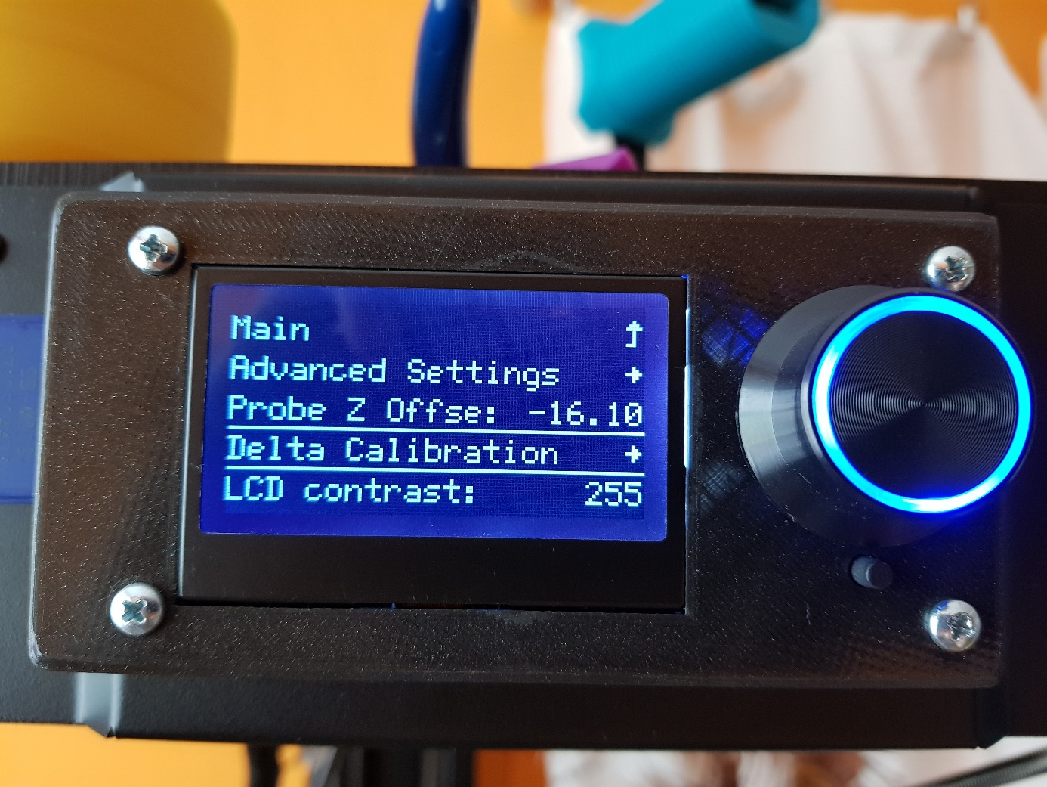

3, Select Auto Calibration

* Printer do Autohome and then stops and ask you for deploy probe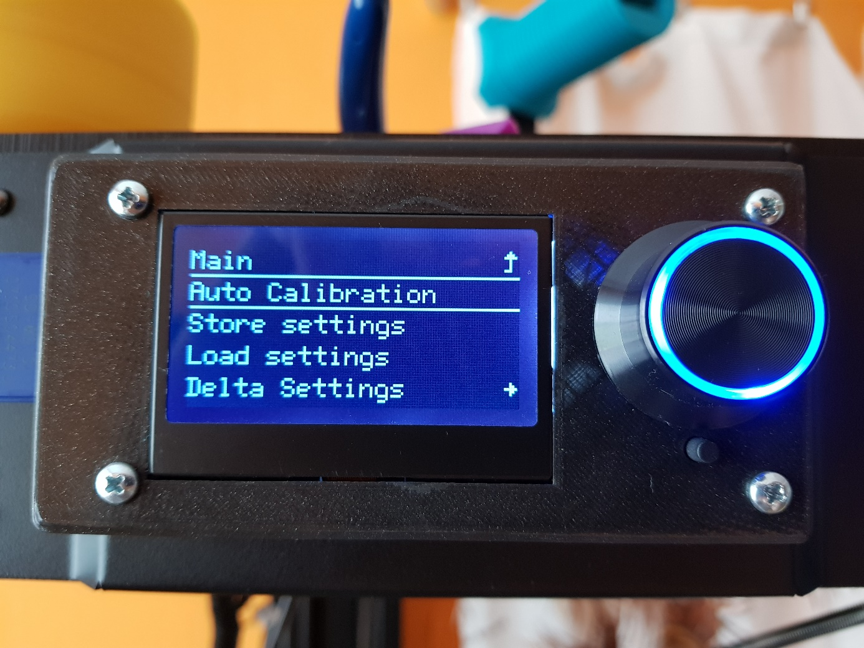

4, Deploy Probe and Confirm 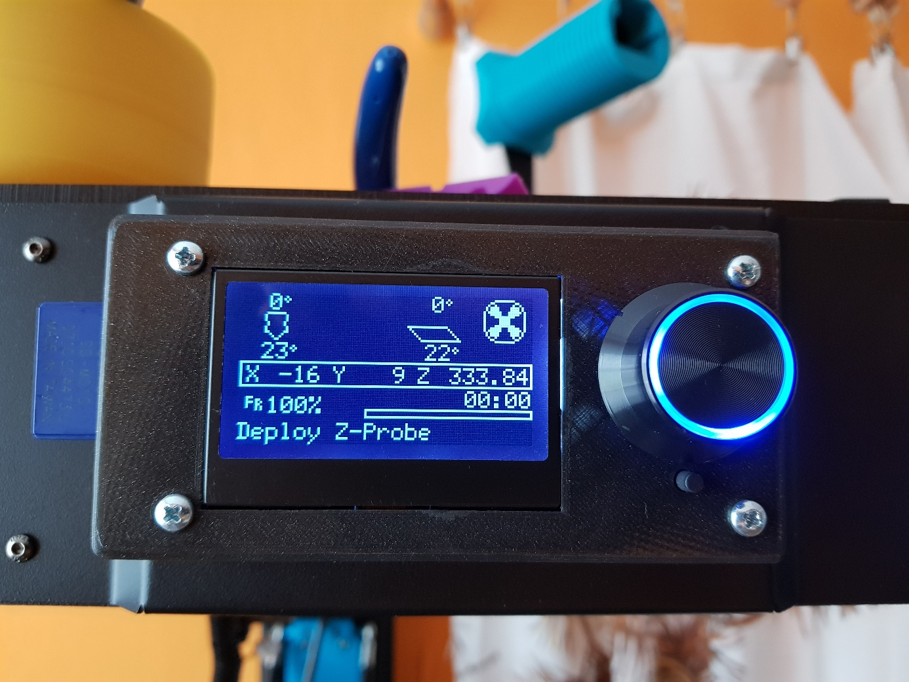  
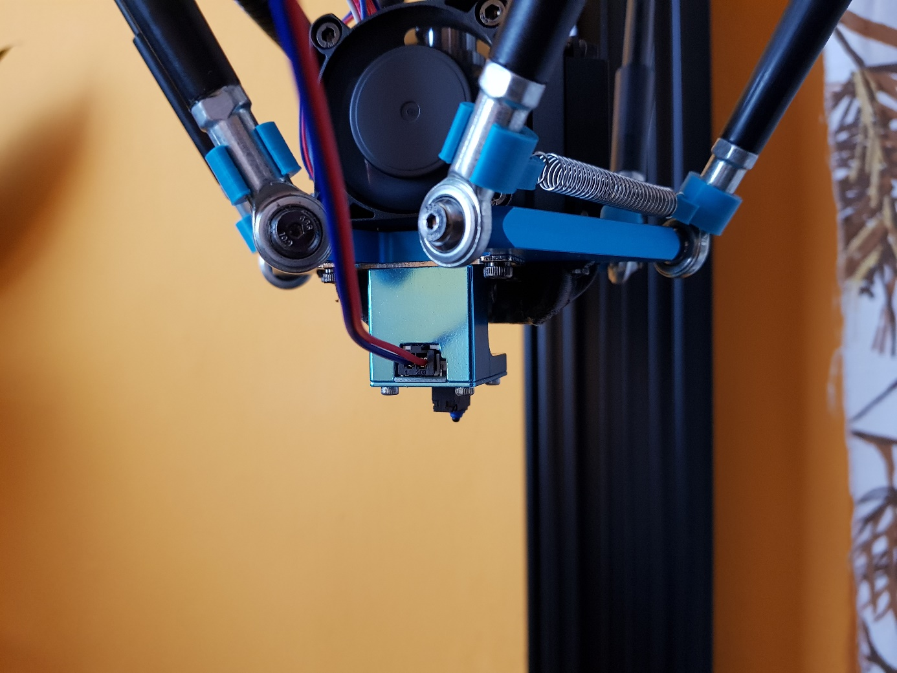

5, Autocalibration Start after you Deploy probe and confirm message it takes several minutes 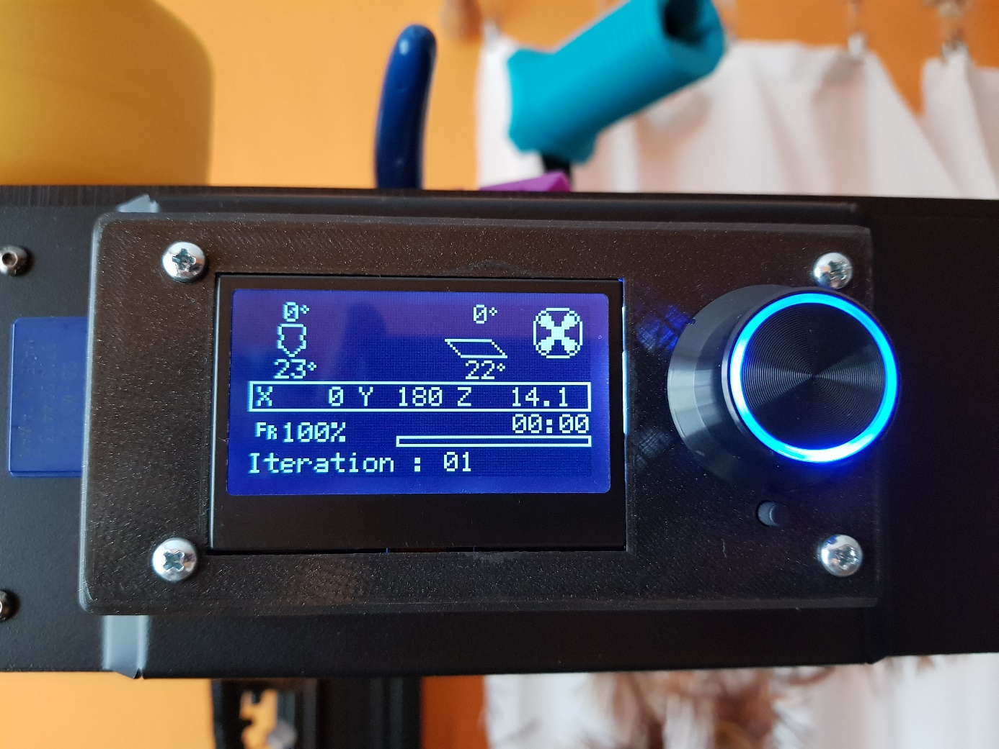

6, After Autocalibration done printer do Autohome and Ask you for stow Probe !

* Now you are calibrated Delta printer next steps will be setup Z0

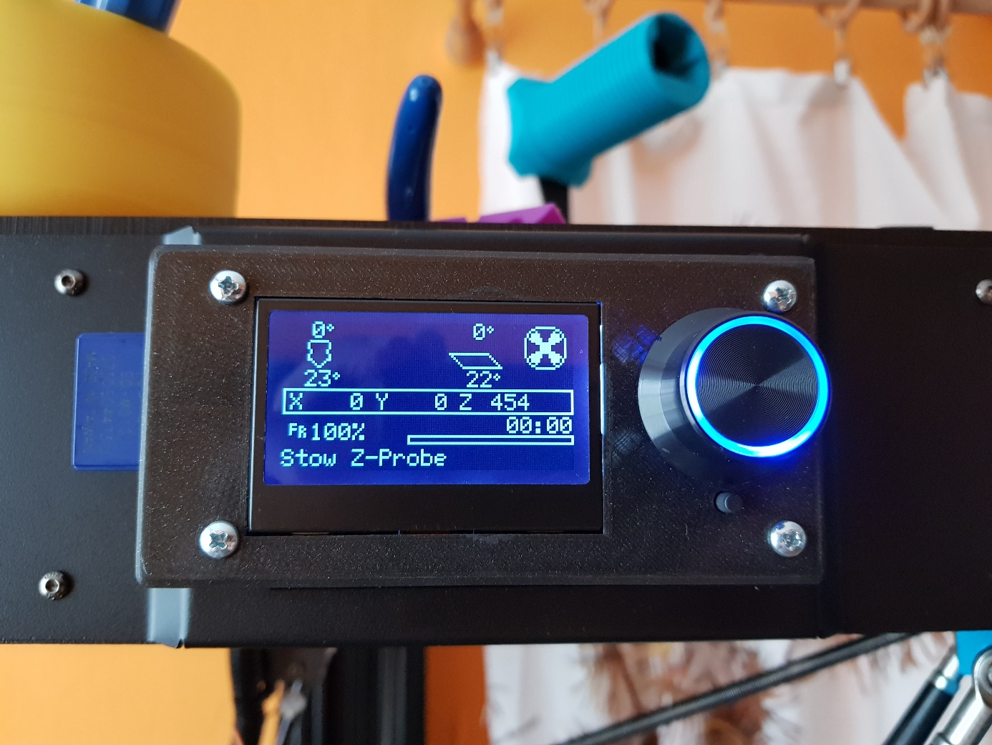

Setup Z0

After we finished Autocalibration process we are ready to setup correctly Z0 which depend on Z-Offset it could be different for each printer.

1, Select Motion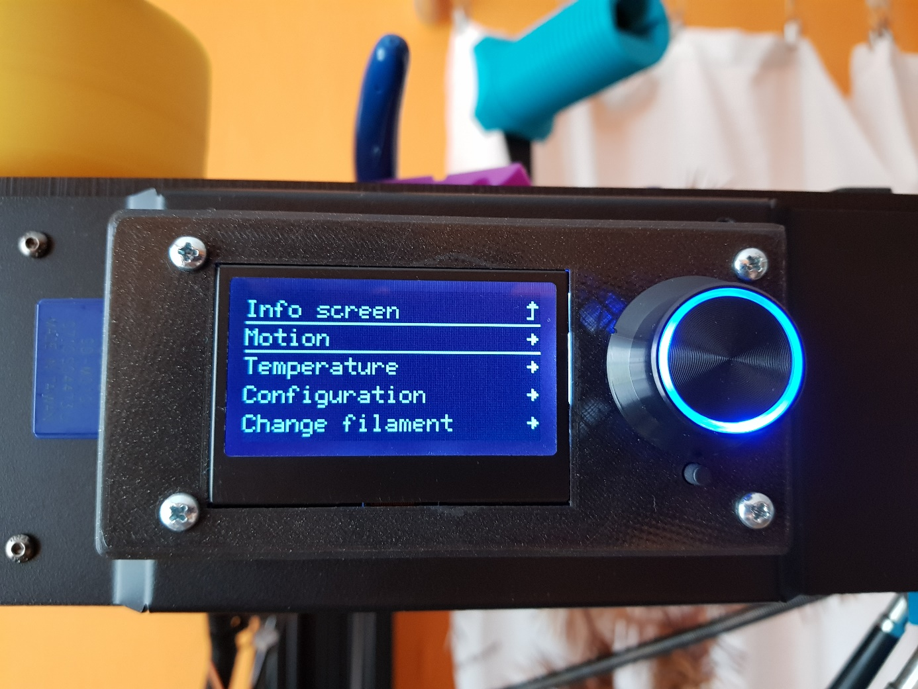

2, Select Move Axis

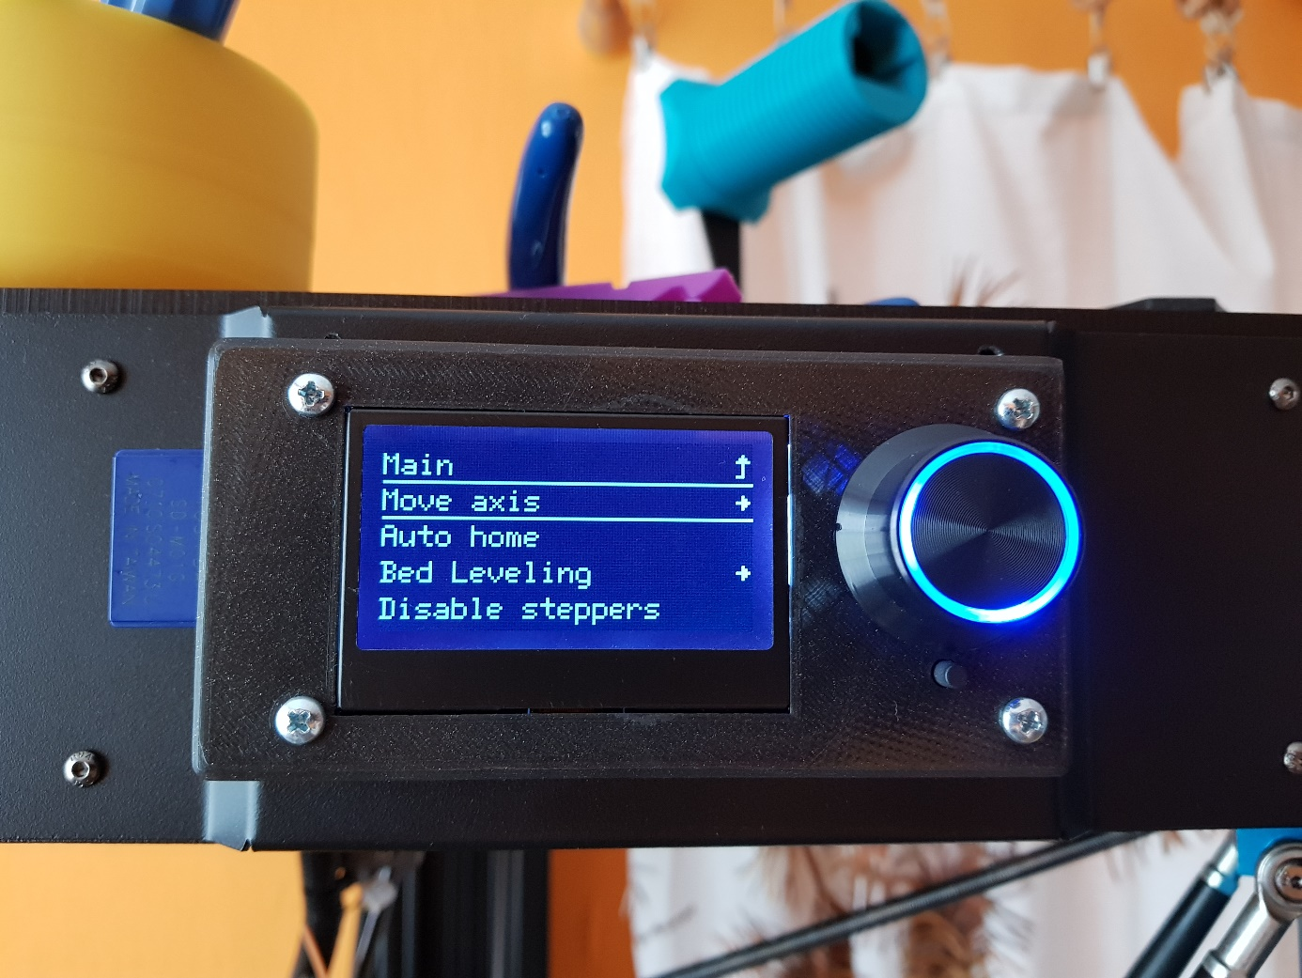

3, Select Move Z

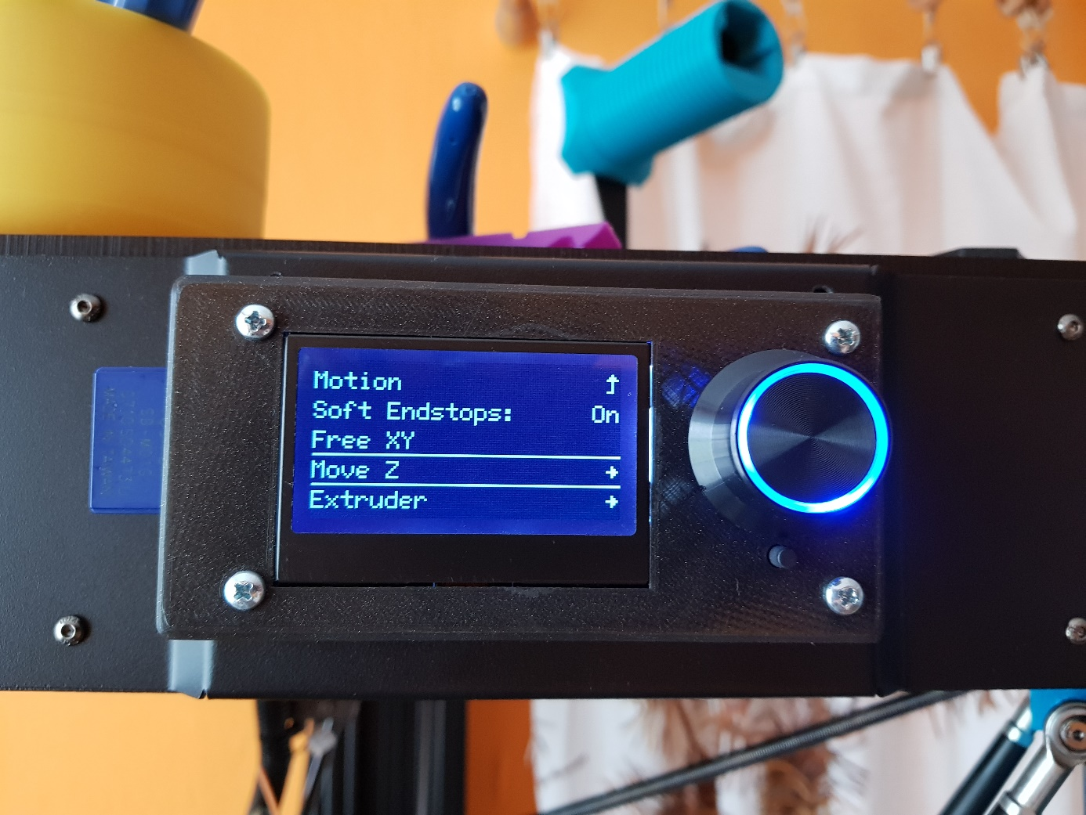

4, Select Move 10mm range

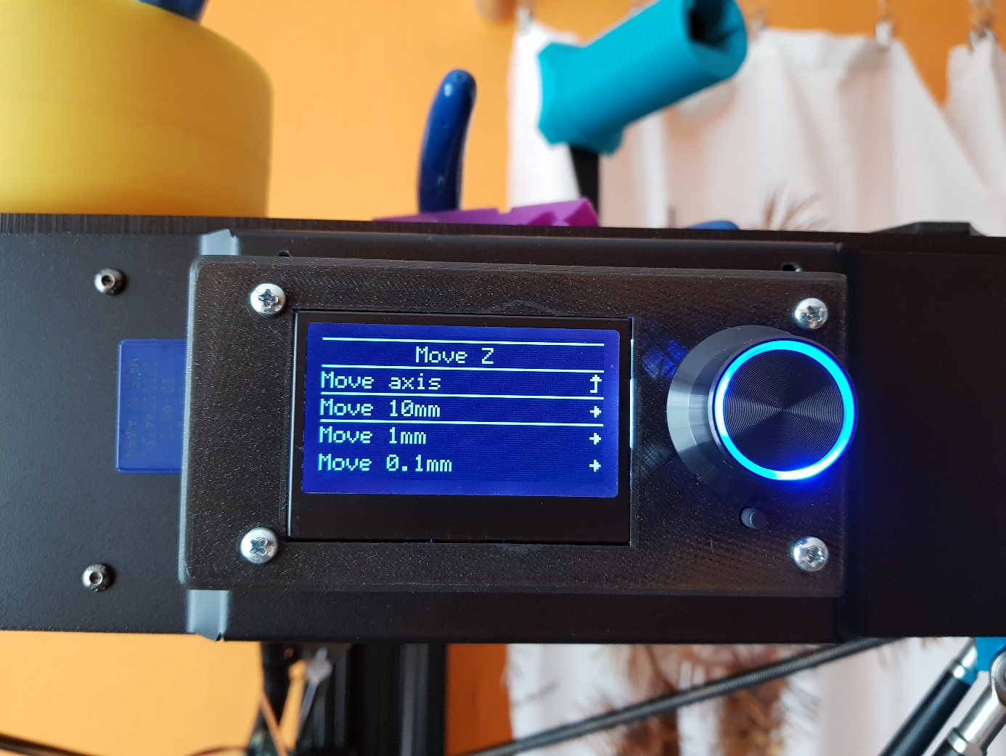

5, Start Slowly Moving for reach cca Z +20mm height (printer nozzle is near bed)

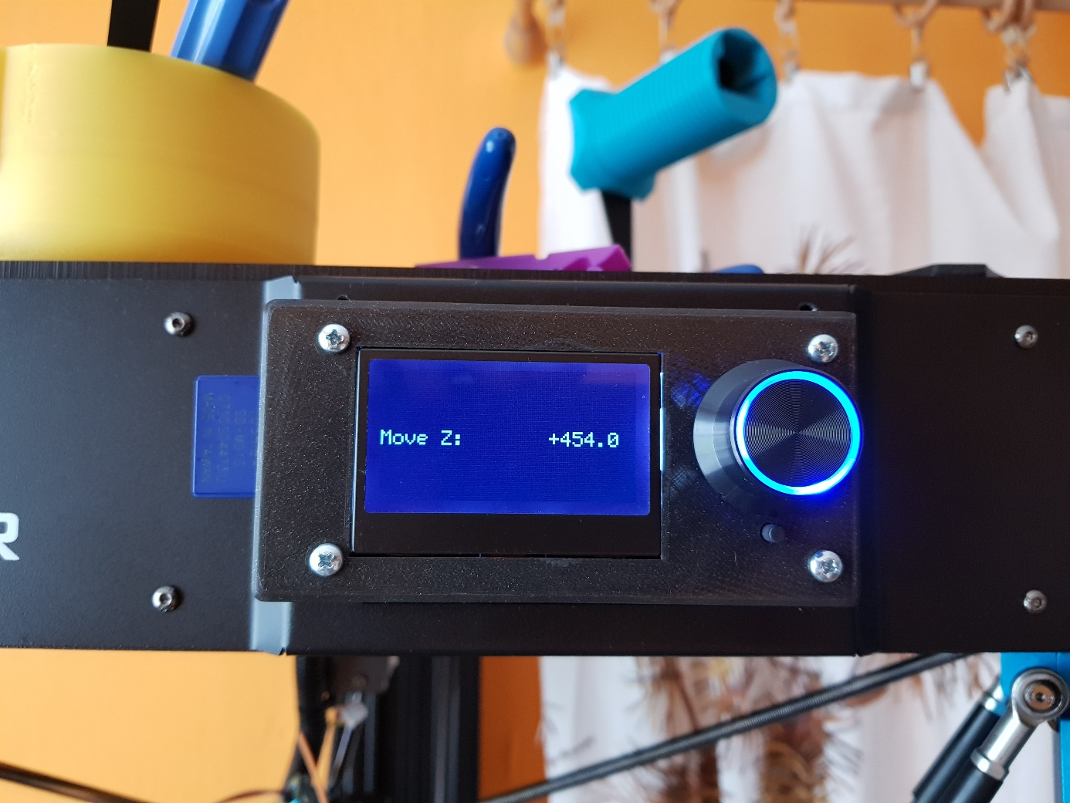

6, Select Move 0.1mm ( be carefull cause if you be in hurry you will drill nozzle to your bed!!)

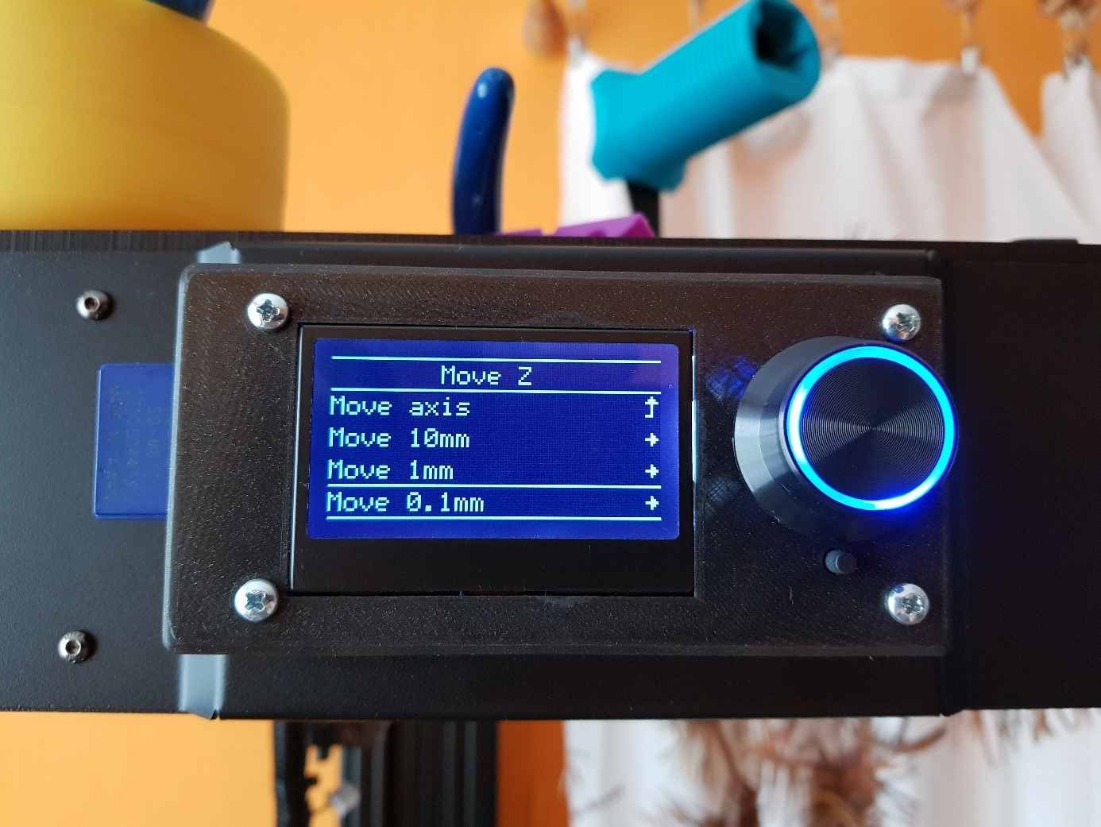

7, Continue slowly goes down to get close nozzle to the bed (prepare piece off paper and move paper between nozzle and bed” usual calibration Z methode)

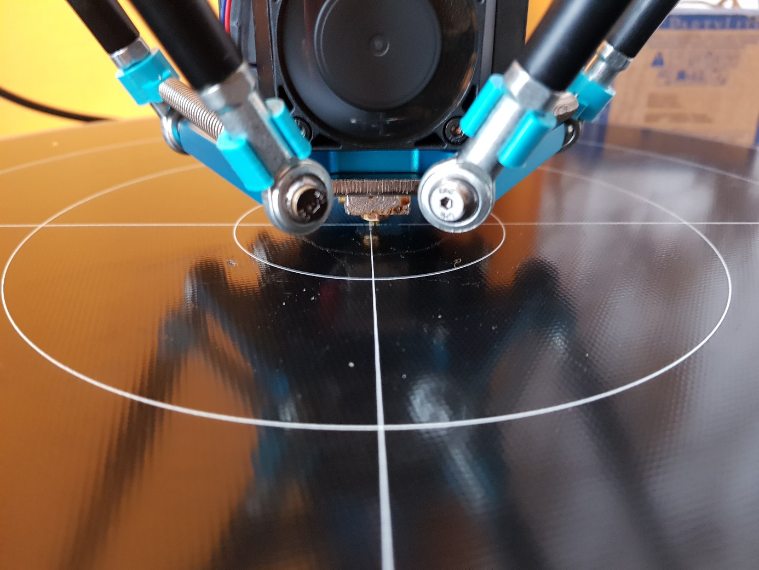

8, For perfect Calibration Z0 you must get Z0 number on display and your nozzle must be in perfect Z0 height (paper must moving smoothly but still ned to be in contact with nozzle.

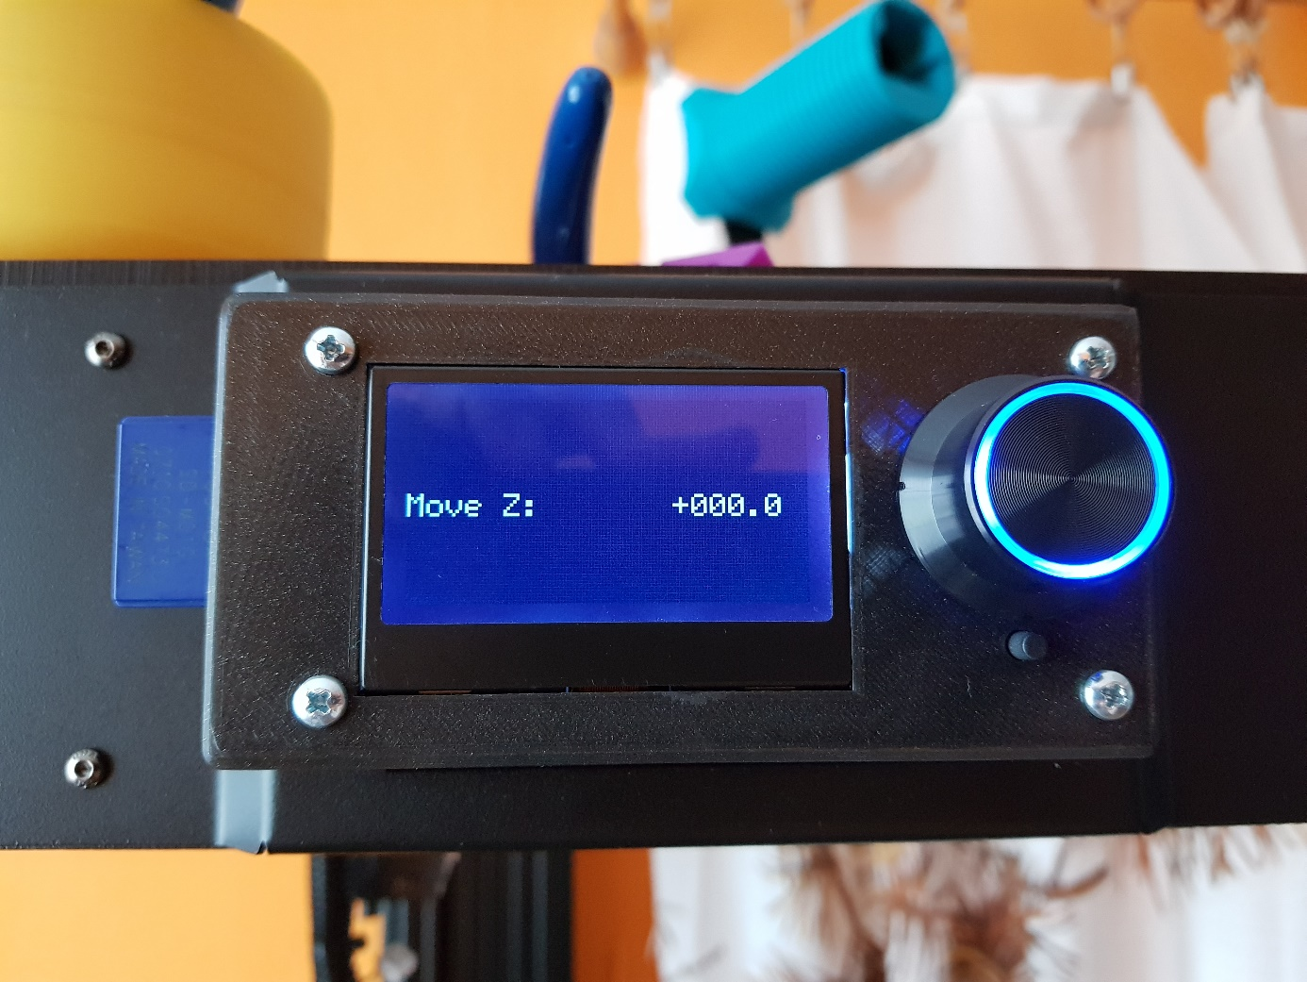

Now two possible scenarios are possible

1. If you are to close (you fell you drill nozzle to bed) you will have some numbers like Z 0.3 or 0.2 you need to setup Z-offset and to lower Z offset number to zero like original umber is  
   Z offset -16.1 if oyu have 0.2 Z you need to setup Zoffset to -15.9 then go autohome and again repet procedure if you get Z0 and check if your Z0 is right as you want.
2. Seccond scenario is opposite. You are too far away bed. You reach Z0 but your nozzle will be in air far away from bed. You need to setup Z offset bigger means  
   Original ZOffset -16.1 set like -16.5 or -16.3 it depends how cca far away you are from bed.  
   And then do Autohome and again repeat procedure if you get Z0 and check if your Z0 is in right height you want.

**Zoffset is in Configuration menu !!**

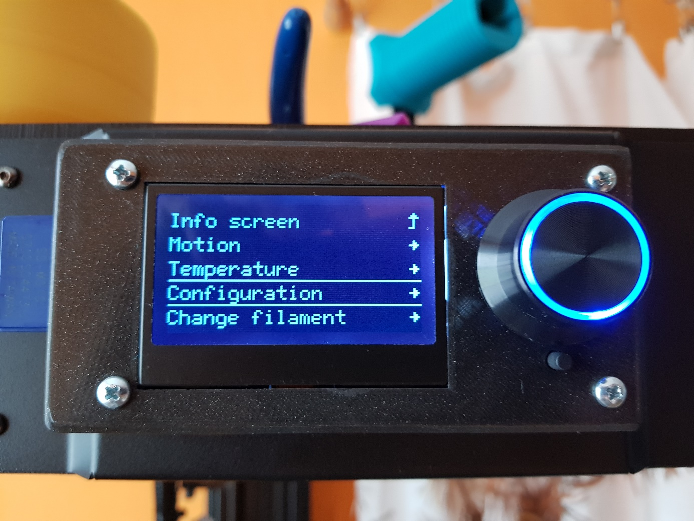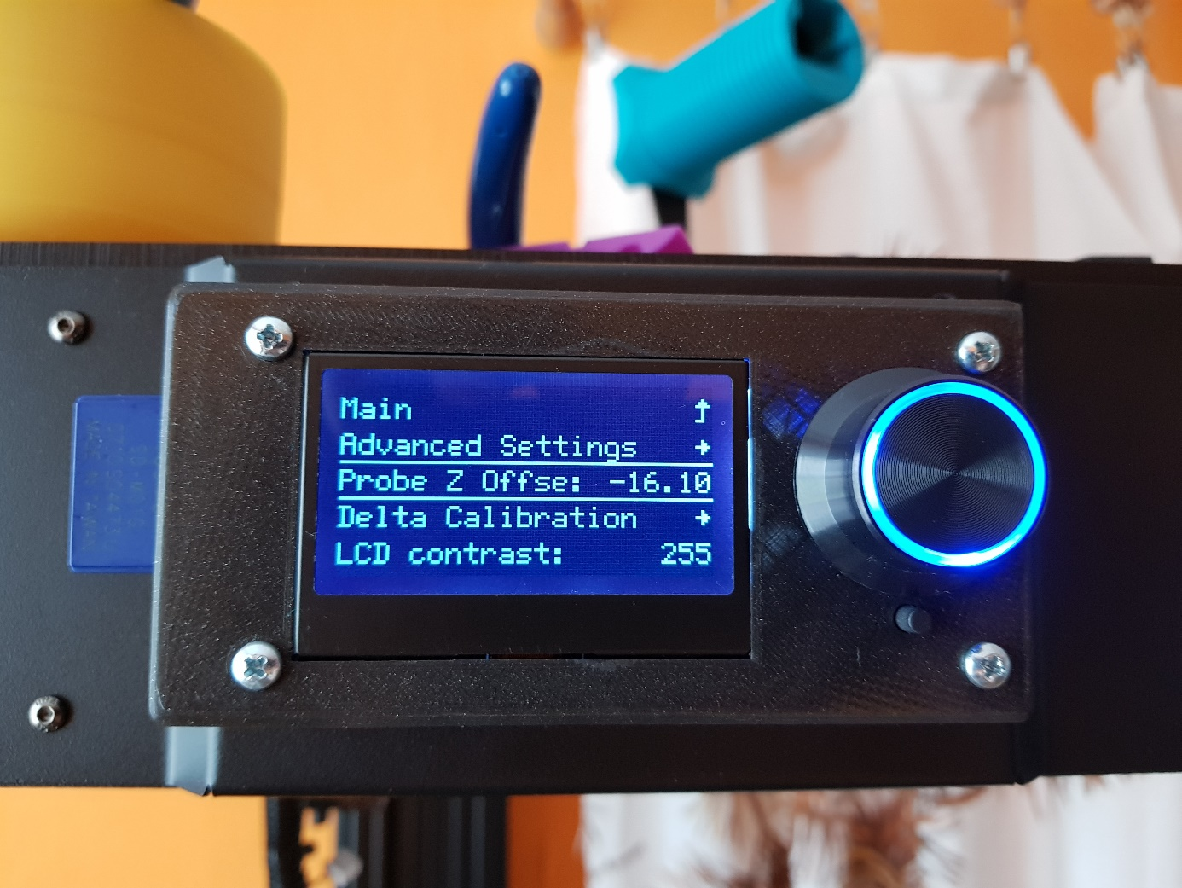

Bed leveling

After correctly setup Z0 pos you are prepared for bed leveling.

For successful bed leveling follow these :

1. Go Autohome
2. 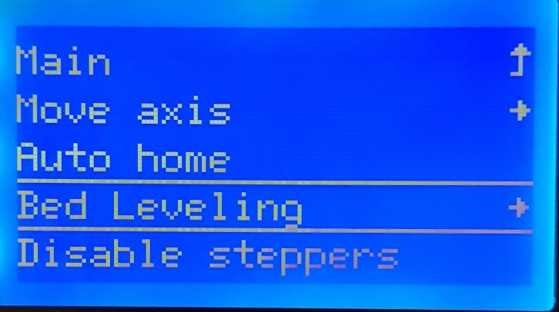Select Bed Leveling
3. 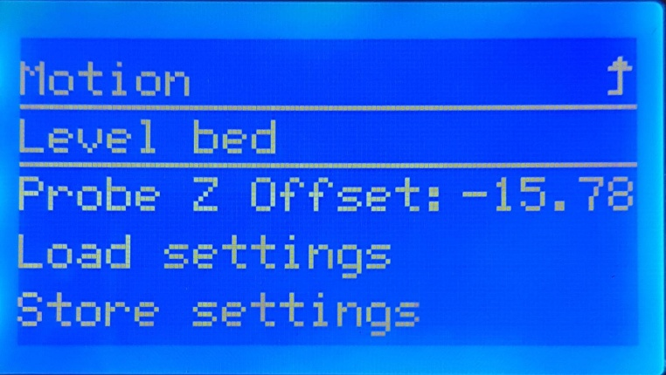Select Bed Leveling
4. 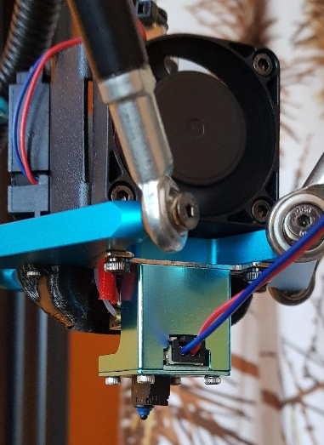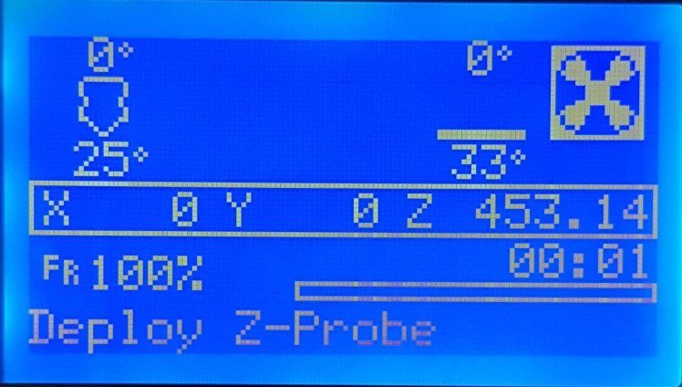Deploy original probe v2
5. Bed leveling start after you confirm message deploy z- probe process start and hot end head go to front side of the bed ( where text ultra base) and start pinking.
6. 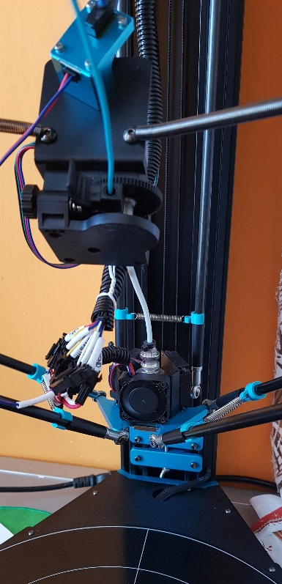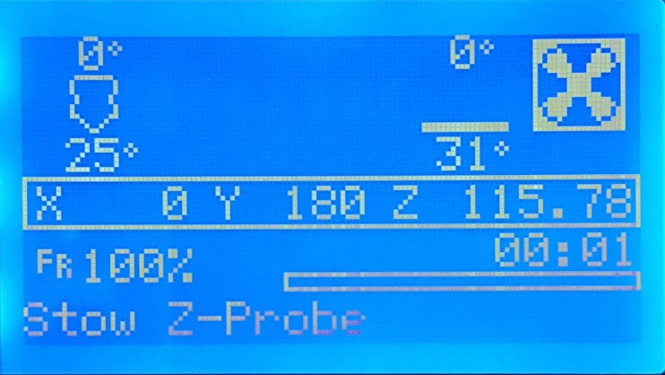After machine finish pinking beep and ask you for stove probe ! DO IT !! OR YOU BADLY FUCK UP PROBE AND BROKE YOUR ARM OR DESTROY SOME PARTS ON HOTEND TOOL!! After you stove probe continue confirm message and printer move little bit down to bed then. After that you are done. Let’s do home pos.